**========================================================================**

**INSTRUCTIONS - PRACTICAL EXAM TRIAL - PRF192**

**- PLEASE READ BEFORE STARTING YOUR EXAM**

**Software Requirements**

* **Dev C++ (4.9.9.2 or 5.11)** on **Windows 7 and above**.

**Students are ONLY Allowed to use:**

* Google Meet, Hangout (for Exam Monitoring Purpose).
* His / her own study materials like presentation slides, notes, sample codes, program examples, electronic books stored on his / her computer only.

**Instructions**

* Step 1: Students download given materials from exam software.
* Step 2: Students read questions and prepare answers in the given template.
* Step 3: Prepare to submit answer:
  + For each question (e.g., question **1**), please create two sub-folders: **run** and **src**.
  + Copy *.**exe** file into **run** folder, *.**c** file into **src** folder.
* Step 4: Submit solution for each question:
  + Choose question number (e.g., **1**) in PEA software, and then attach corresponding solution folder (e.g., **1**). Click Submit button to finish submitting this question.
  + 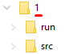

**Notes**

* Solutions will be marked by Automated Marking Software.

**========================================================================**

**(1 mark, file to be edited: Q1.c)**

Users are required to enter two integer variables a and b using the keyboard (STDIN).

Please check the following conditions:

• If a is greater than or equal to b then print: a>=b

• If a is less than b then print: a<b

Below is an example of how the program will run:

Enter the value 1 for ‘a’ and the value 4 for ‘b’

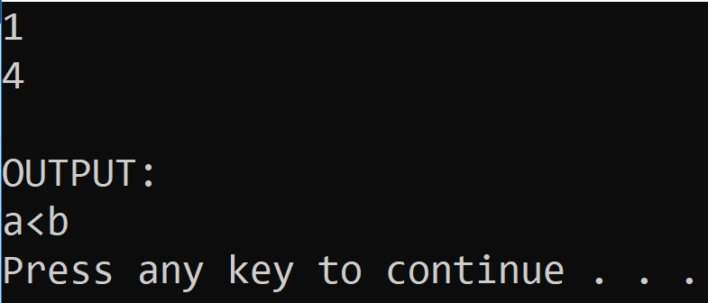

**(1 mark, file to be edited: Q2.c)**

Users are required to enter a non-negative integer variables n using the keyboard (STDIN).

The system displays the sum of the last three even numbers in range from 0 to n.

Below is an example of how the program will run:

Enter the value 6 for ‘n’

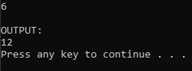

**(1 mark, file to be edited: Q3.c)**

Your program allows users to enter 4 characters.

The system displays the entered characters following alphabetical order. There is a space character in between any two adjacent characters.

Below is an example of how the program will run:

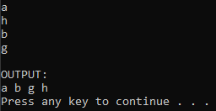

**(2 marks, file to be edited: Q4.c)**

Your program allows users to enter 7 integer numbers into an array.

The system performs selection sorting of the array in ascending order then prints the sorted array. There is a space character between any two adjacent numbers.

Below is an example of how the program will run:

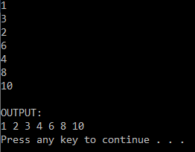

**(2 marks, file to be edited: Q5.c)**

Your program allows users to enter array of n integers, where n is entered by the user (n<20).

* If the array is symmetric, the program displays: 1
* Otherwise the program displays: 0

Below is some examples:

|  |  |
| --- | --- |
| n=5  array = {2,2,3,2,2}, symmetric | n=5  array = {2,2,3,4,2}, asymmetric |
| n=4  array = {1,2,2,1}, symmetric | n=4  array = {2,2,1,2}, asymmetric |

**(2 marks, file to be edited: Q6.c)**

Your program allows users to enter 5 person names into an array of strings. The program performs sorting of the array in ascending order then prints each element of the array followed by a space character.

Below is an example:

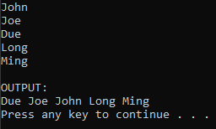

**(1 mark, file to be edited: Q7.c)**

Your program allows users to enter a string with an odd number of characters (5<n<20). The program then displays the middle 5 characters of the string.

Below is an example:

